|  |  |
| --- | --- |
| The symphony run  Game Design Document | Marouen Abdi (Game designer)  Emerson Navarro (Game developer)  Gabriel Dario Chanchay Tituaña (Game developer)  Development of Games for Mobile Devices |

1. **Title**
   1. **Game Title**

The Symphony Run

* 1. **Intend Game Systems.**

Android and IOS.

* 1. **Target Age of Players.**

The target audience is child between 6 and 12 years, even though it can be played for all ages.

* 1. **Age Rating.**

The content of Symphony Run is classified by ESRB as Everyone, which means that it is generally suitable for all ages. May contain minimal cartoon, fantasy or mild violence and/or infrequent use of mild language.

1. **Game Outline**
   1. **Game Story Summary.**

There was a cloudy night in Vienna, Mozart was really tired after a long day of composing sonatas and Waltzes Wolfgang Amadeus Mozart was really tired Hence, he went to sleep, while he was sleeping, he had a nightmare in which there were little bats that were stealing his compositions. He realizes and follow them through the city just with a baton as a weapon. He follows them in order to recover the compositions.

* 1. **Game Flow.**

The game flow for the “The Symphony Run” (TSR) can be separated in two main actions: The Level Selection and the Gameplay, itself.

During the Level Selection action, the user can interact with buttons to start a level between all the levels available to be played as showed in Figure 1.

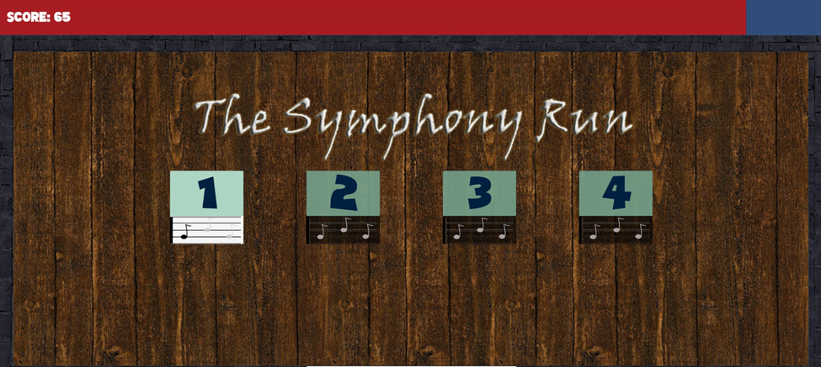

Figure 1 - Level Selection

Not all the levels are unlocked at the beginning, but only the first one. To unlock the next levels the user needs to play the levels and collect items. When this happens, takes in place the Gameplay action.

This action is based on a 2D runner game such as Super Mario Run[1] or Banana Kong[2]. As happens any game of this type, where the character is always running forward and looking for collectibles throughout the level. However, while in some types of runner games there is no end level, which means that the player can still playing until he dies, in the TSR all the levels have an end – which is represented by a Piano during the gameplay, as showed in section X. Also, differently of Super Mario Run, where enemies don’t cause damage to the player, in TSR the enemies can take damage to the Player (this behavior will be covered in section X).

Throughout the level there are two types of collectible objects that can be picked by the user: the normal notes and the clefs. While the normal notes increase the score of the player, the clefs are required to unlock the next level.

Based on that, the Game Flow of TSR can be summarized as showed in Figure 2.

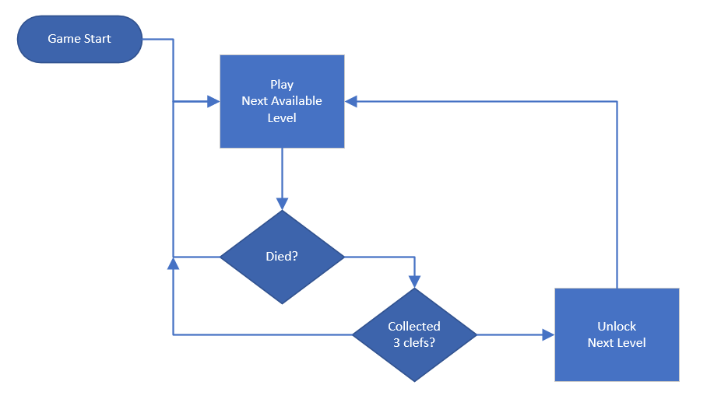

Figure 2 - Game Flow Diagram

1. **Character.**

In this section will be presented questions related to the character in TSR.

* 1. **Description**

As previously mentioned in section 2.1 the player of TSR is **Wolfgang Amadeus Mozart,** the famous composer. Mozart was a prolific and influential composer of the classical era.

Born in [Salzburg](https://en.wikipedia.org/wiki/Salzburg), Mozart showed prodigious ability from his earliest childhood. Already competent on [keyboard](https://en.wikipedia.org/wiki/Keyboard_instrument) and [violin](https://en.wikipedia.org/wiki/Violin), he composed from the age of five and performed before European royalty. At 17, Mozart was engaged as a musician at the Salzburg court but grew restless and traveled in search of a better position. While visiting [Vienna](https://en.wikipedia.org/wiki/Vienna) in 1781, he was dismissed from his Salzburg position. He chose to stay in the capital, where he achieved fame but little financial security. During his final years in Vienna, he composed many of his best-known [symphonies](https://en.wikipedia.org/wiki/List_of_symphonies_by_Wolfgang_Amadeus_Mozart), [concertos](https://en.wikipedia.org/wiki/List_of_compositions_by_Wolfgang_Amadeus_Mozart#Concertos), and [operas](https://en.wikipedia.org/wiki/List_of_operas_by_Wolfgang_Amadeus_Mozart), and portions of the [Requiem](https://en.wikipedia.org/wiki/Requiem_(Mozart)), which was largely unfinished at the time of his early death at the age of 35. The circumstances of his death have been much mythologized.

* 1. **Art Concept**

The intended art concept for the character was to be a 2D cartoon-like version of Mozart. The images of [1] were used as inspiration for the composition of the art to the character on TSR. In Figure 3 is presented the art used as concept and in Figure 4 is presented the Mozart character of the game.

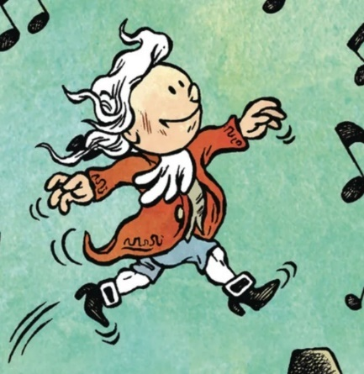

Figure 3 - Young Mozart - Art Concept.

Source: [1]

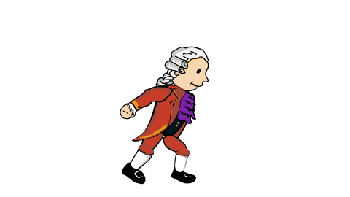

Figure 4 - The Symphony Run - Mozart character

* 1. **Character Controls**

As happens in the most runner games, the main movement of the character is to run forward and it is controlled by the system.

Also, in TSR the character can Jump. This movement is controlled by the player through an interface component presented in the screen, as shown in Figure 5.

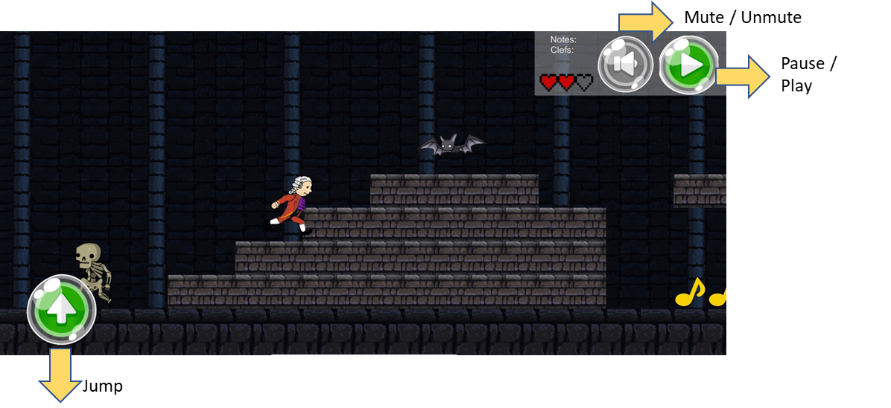

Figure 5 - Character Control

* + 1. **Wall jumping**

A special movement that the player can perform is called wall jump. This is performed when the user jumps while the character is facing a wall.

When this moment is executed the character flips back and is throwed to the opposite side. This movement ends as soon as the character touch the ground when the character flips to the right side and starts to run again. This movement is illustrated in the figure X.

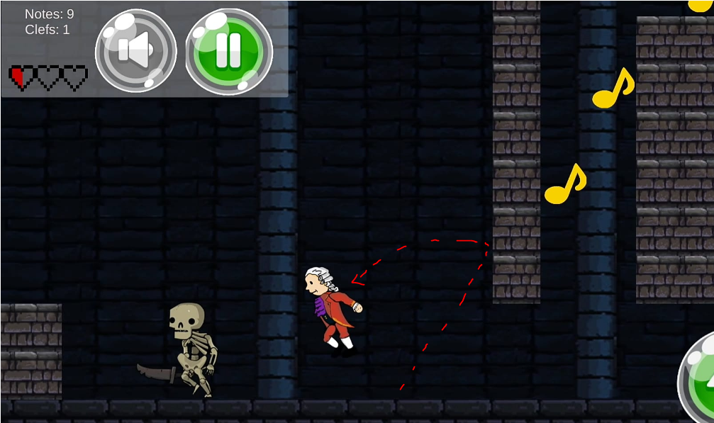

Figure 6 - Wall Jump

1. **Game Play**

In this section we will discuss the gameplay of the game.

* 1. **Genre.**

As previously discussed in section XX TSR is a runner game, just like Super Mario Run and Bana Kong. This kind of games can be sub-categorized in endless runner games (when the levels has no end, end the game stops only when the user dies) and end runner games (when the levels has end that needs to be reached).

Based on this, this game can be classified as an end level runner game.

* 1. **How to play.**

At first the user will be presented with the Level Selection screen from where he needs to pick the desired available level.

In each level, Mozart will be running, and the player can control the jump by pressing a button to jump over the enemies.

The player can also collect notes that increases the overall score and recover the life and clefs, which is used to unlock the next level.

The collected clefs in a specific level is only considered if the player finishes the level. It means that if the player dies the collected clefs in that section will not be saved. It is worth to highlight that the player needs to collect all the 3 red clefs in each level to unlock the next level.

* 1. **Levels.**

The game will have 4 levels each one, in each level Mozart need to collect notes and reach the end of the level.

The main screen of the game is presented in Figure 7.

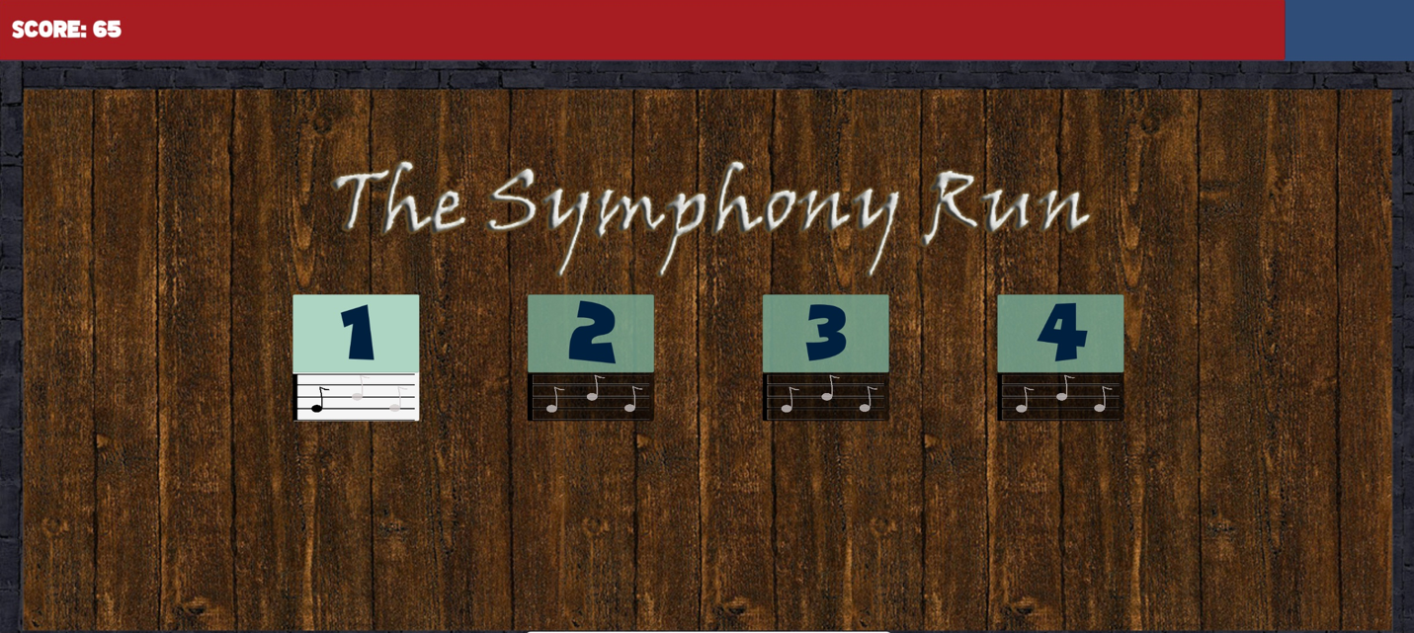

Figure 7 - Main Screen

When the user reaches the end of the level a screen is presented as show in Figure 8.



Figure 8 - Level Complete Screen

Also, if the user dies a screen is presented as shown in Figure 9, from where the user can back to the main screen or replay the same scenario.



Figure 9 - Game Over screen

1. **Game World.**

In this section will be presented the topics related to the Game World.

* 1. **Environments.**

The environments on each level tries to represent the inner of 17th century castle, with stone bricks and platforms as shown in Figure 10.

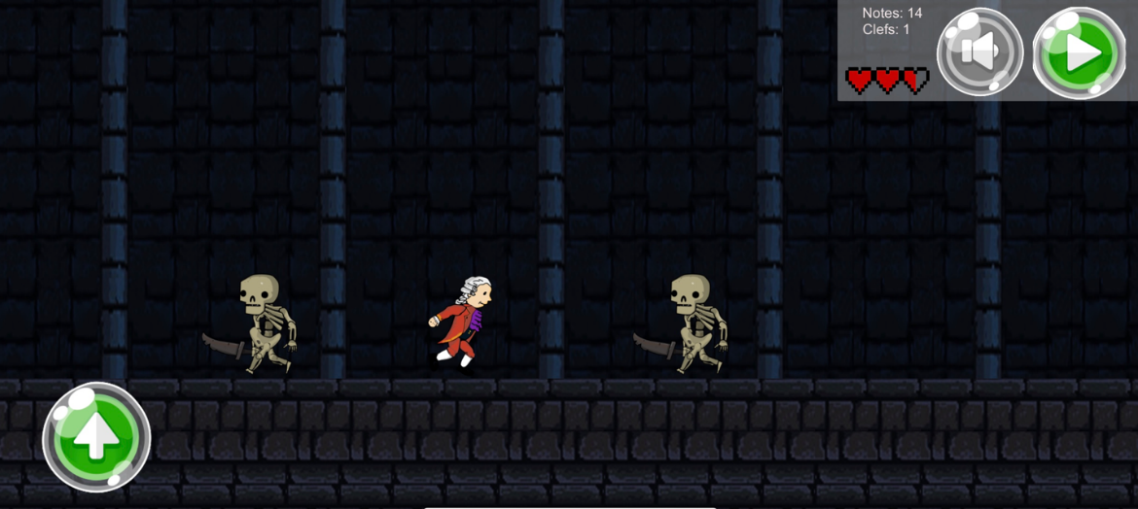

Figure 10 - Environment

The platforms in each level are disposed in different places in order to create different challenges by implementing different walls and pitfalls.

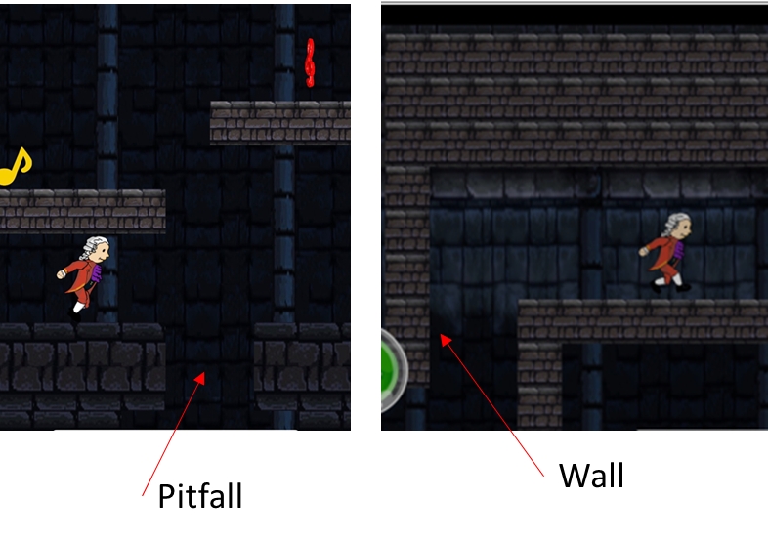

Figure 11 - Challenges details

* 1. **Music.**

All music that the game will have will be Mozart compositions.

Each stage will be a composition of Mozart, each stage has 3 level, each level will be a part of the composition. Each level of this stage will have a part of the composition.

Stage 1: Turkish March.

Stage 2: Le nozze de Figaro.

Stage 3: Magic Flute.

Stage 4: Symphony 40 in G minor.

The music that will be played while the game is loading, in a pause or changing the settings of the game will be the Piano concert N 21.

There will be different music for each stage of the game.

The music that will be played when the user die is the Requiem Lacrimosa.

1. **Gameplay Mechanics.**
   1. **Mechanics.**

The player will be able to jump through platforms collecting all notes and clefs. He needs to avoid the enemies because they could harm him. At the end of each level he needs to reach his piano to pass to the next level.

* 1. **Power-ups.**

Mozart will start with 3 hearts, if he loses all of them the game is over. But when he collects 20 notes from the level, he will have an extra one.



* 1. **Collectibles.**

There will be two different types of collectible items on the levels: the musical notes and the musical clefs, as shown in figure below.



The user can collect as much as he can of these musical notes, that will be counted to increase the score and, as already mentioned, recover hearths.

The user can also collect all the musical clefs per level in order to unlock the next level, as mentioned in section 4.2.

* 1. **Lives**

The player will have 3 hearths, and if he loses one, he will be back in the same spot where he died. If the three of them are consumed the game is over and need to start the game again from the beginning.

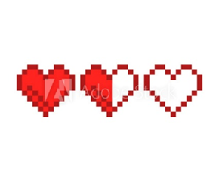

1. **Enemies**

There will be 2 different types of enemies as shown below and all enemies have an automatic cycling movement of 3 position in x vector.

All these enemies are being destroyed form the game scene as soon as the camera loses focus on them.

* 1. Bats. -When the bats touch the player, it took 50% of a heart life of the player.

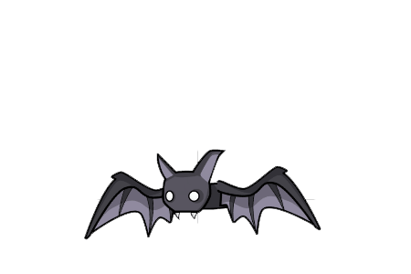

* 1. Skeletons. – The skeletons will be walking in the level trying to stop Mozart from collecting the notes. When touching the player, they will take a full heart life.

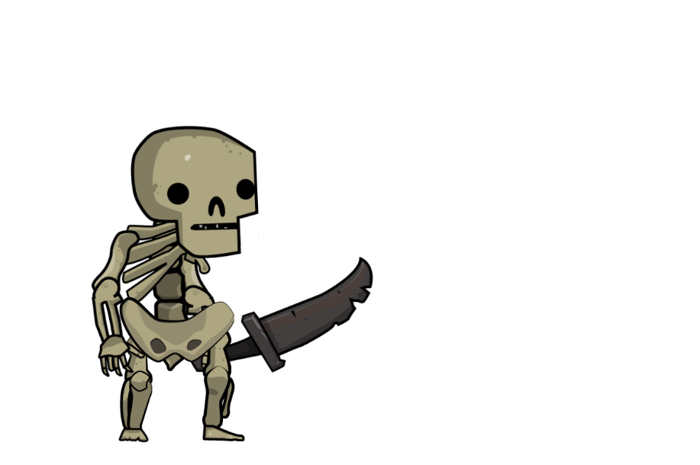

1. **Monetization.**

The game will be free, but the player will be able to buy new outfit for Mozart and new environments.

1. <https://supermariorun.com/en/index.html>
2. [https://play.google.com/store/apps/details?id=com.fdgentertainment.bananakong](https://play.google.com/store/apps/details?id=com.fdgentertainment.bananakong&hl=en)